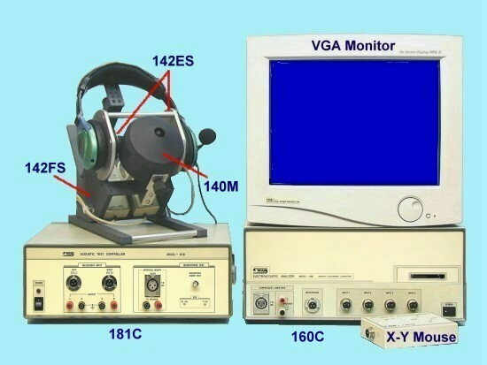
Model ：- Type 1600CHM
Combination items for testing the headset with microphone

Items of combination: 160C+181C+142ES (2 sets) +142FS +140M ( See below figure)
Test object: Headset with microphone
Explanation: (a) Has analysis and statistics (Cp, Ca, Cpk) function
(b) Functions:
( I ) Headphone characteristics :
Frequency Response :
20Hz ~ 20KHz by using Model-142ES
Sensitivity
AC Impedance Test ( 2 ~ 1000 Ohms )
DCR Test ( 2 ~ 1000 Ohms )
Polarity Test
Fo Test
PAP Test (Peak Acoustic Pressure Test)
Harmonic distortion test or Buzz and rattle test.
Distortion Curve
Balance test
( II ) Microphone characteristics :
Frequency Response (100Hz ~ 8KHz)
Sensitivity
ECM DC current
Harmonic distortion test
Supply power voltage to ECM: +0.9V ~ +9V adjustable
Loading resistor to ECM: 180 Ohms ~ 9 K Ohms, adjustable

The Figure of combination: 160C+181C+142ES (2 sets) +142FS +140M

Model-160C | Model-181C | Model-142ES *2 + 140M + 142FS
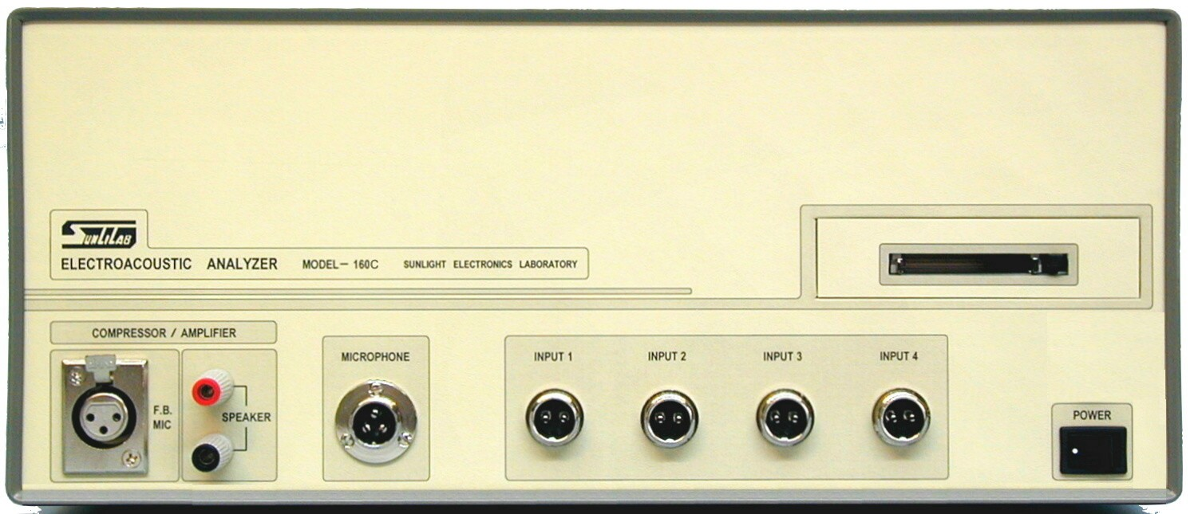 | 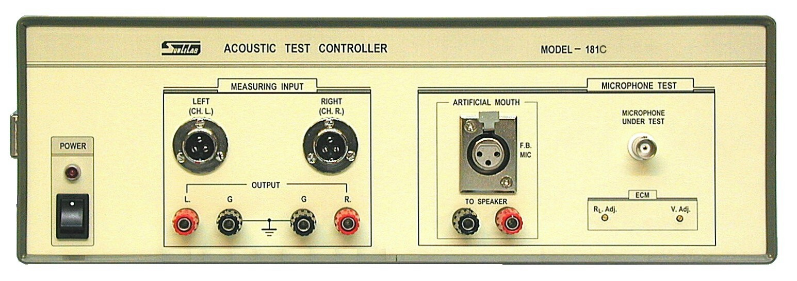 | 