Model ：- Type 1600CS

Combination items for loudspeaker or loudspeaker box system testing

Items of combination: 160C + 181C + 8120H (one set) (See below figure)

Test object: Loudspeaker or loudspeaker box system.

Explanation: (a) Testable functions:
Frequency Response (20Hz ~ 20KHz) & Sensitivity
AC Impedance Test ( 2 ~ 1000 Ohms )
DCR Test ( 2 ~ 1000 Ohms )
Polarity Test
Fo Test
Harmonic distortion or buzz & rattle test
Distortion Curve

(b) Has analysis and statistics (Cp, Ca, Cpk) function.

The Figure of combination: 160C + 181C + 8120H (one set)

Model-160C | Model-181C | Model-8120H
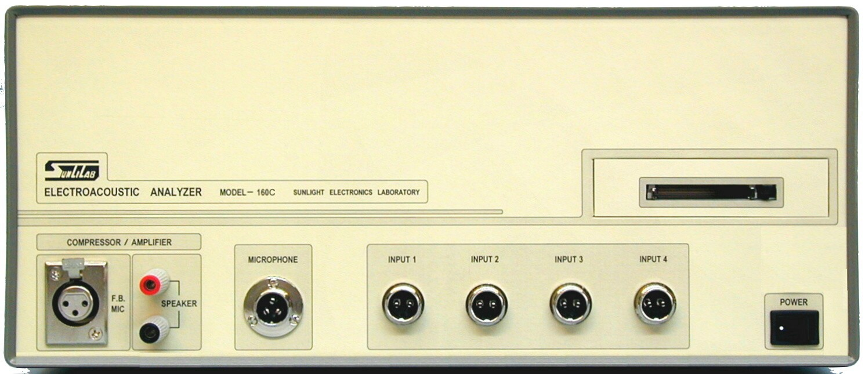 | 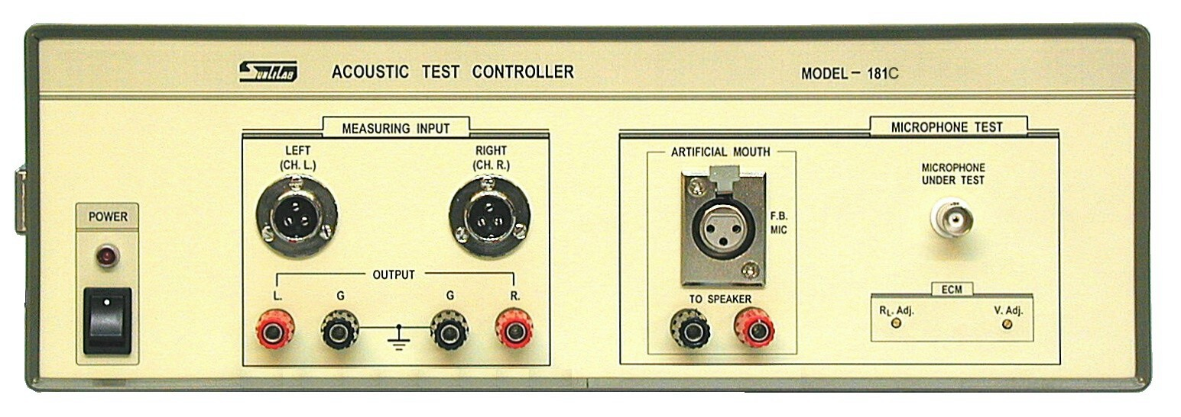 | 